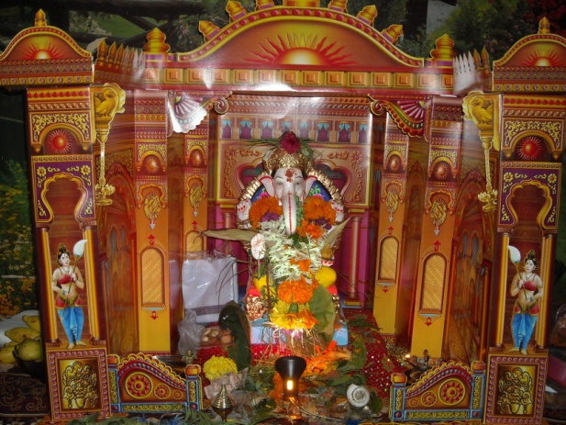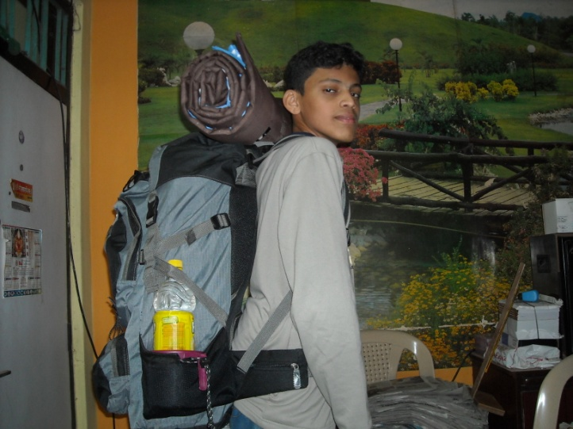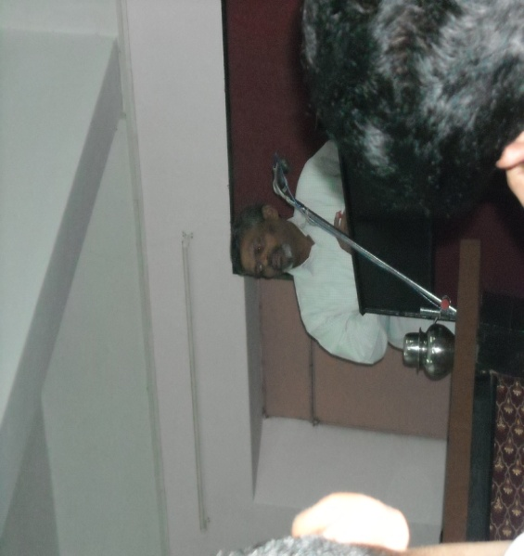

|  |  |  |  |  |  |
| --- | --- | --- | --- | --- | --- |
| **October 2012** | | | | | |
| **Sunday** | **1** | **8** | **Picture 445.jpgPicture 475.jpg**  **15** | **22** | **29** |
| **Picture 325.jpgMonday** | **2** | **9** | **16**  **17** | **23** | **30** |
| **Tuesday** | **3** | **10** | **Picture 278.jpg** | **24** | **31** |
| **Wednesday** | **4** | **11** | **18** | **25** |  |
| **Thursday** | **5** | **12** | **19** | **26** |  |
| **Friday** | **6** | **13** | **20** | **27** |  |
| **Saturday** | **7** | **14** | **21** | **28** |  |